**Tugas week 13 advanced bda Christopher Darren 00000054804**

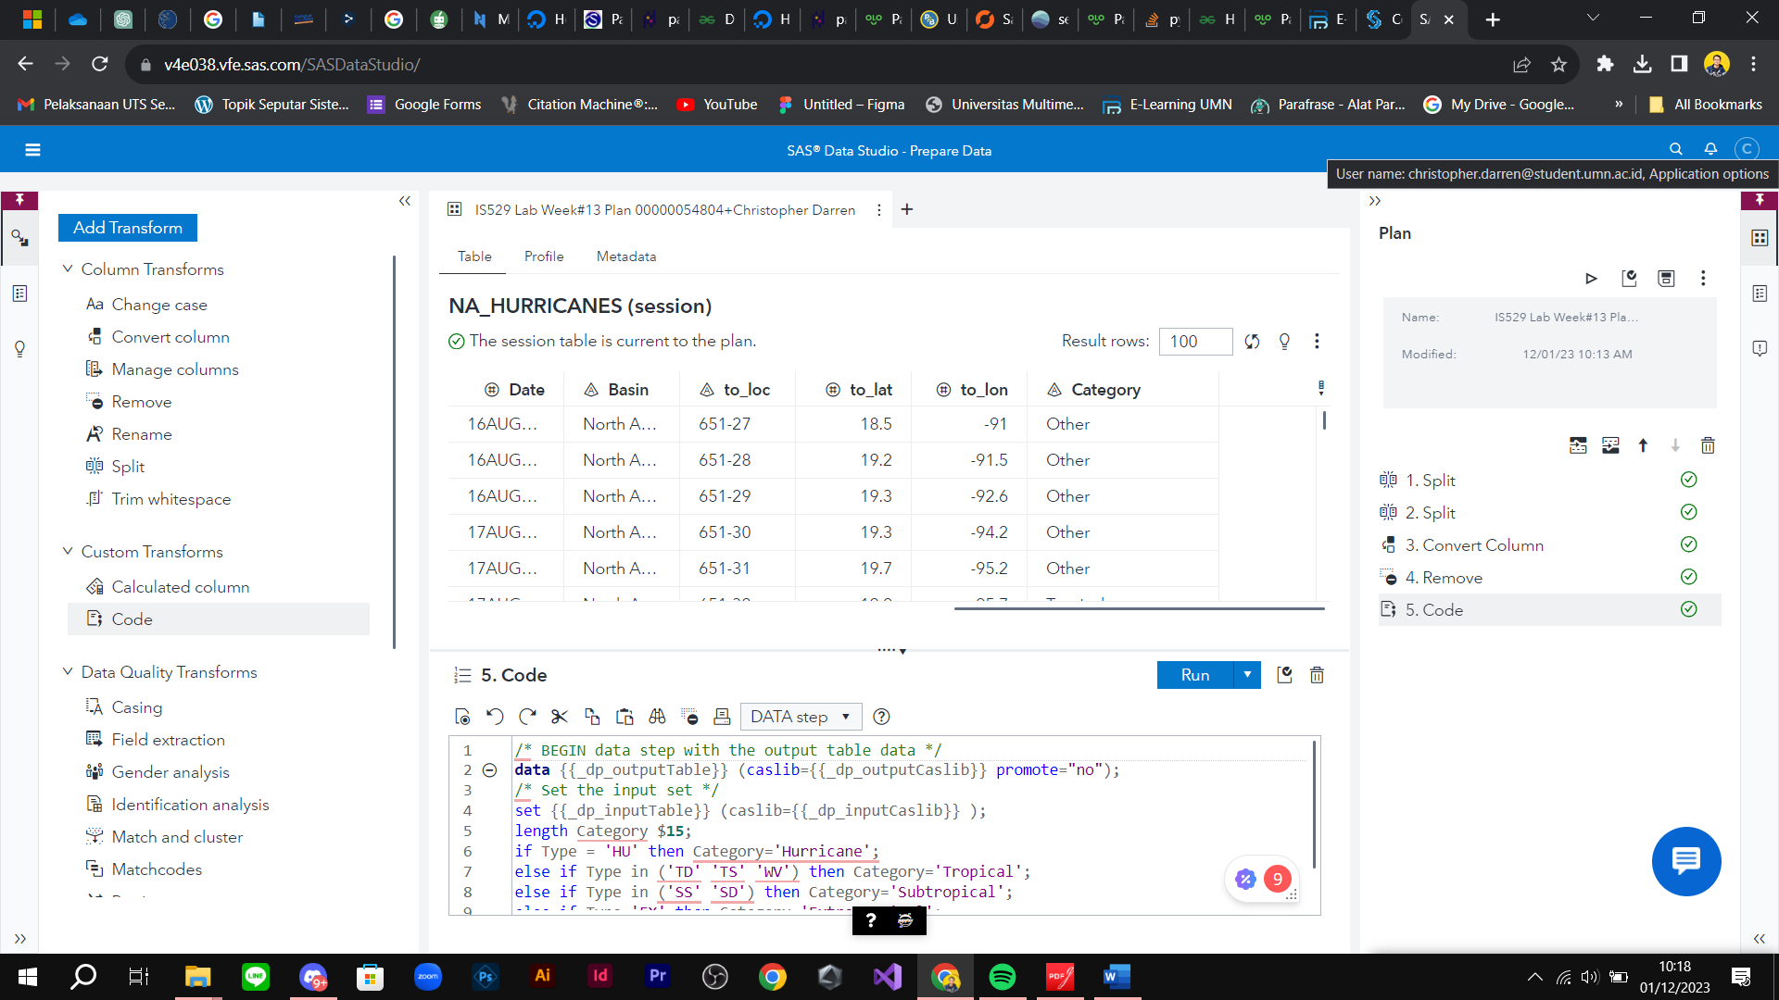

Figure A

Answer the following questions:

**1) Which states did Hurricane Matthew hit in 2016? What was the maximum wind speed? How**

**was Hurricane Matthew categorized?**

State: A little bit in Florida outers, Guantana, Departement De La Grande Anse

Maximum Wind Speed : 145

Categorized: Extratopical, Hurricane & Tropical

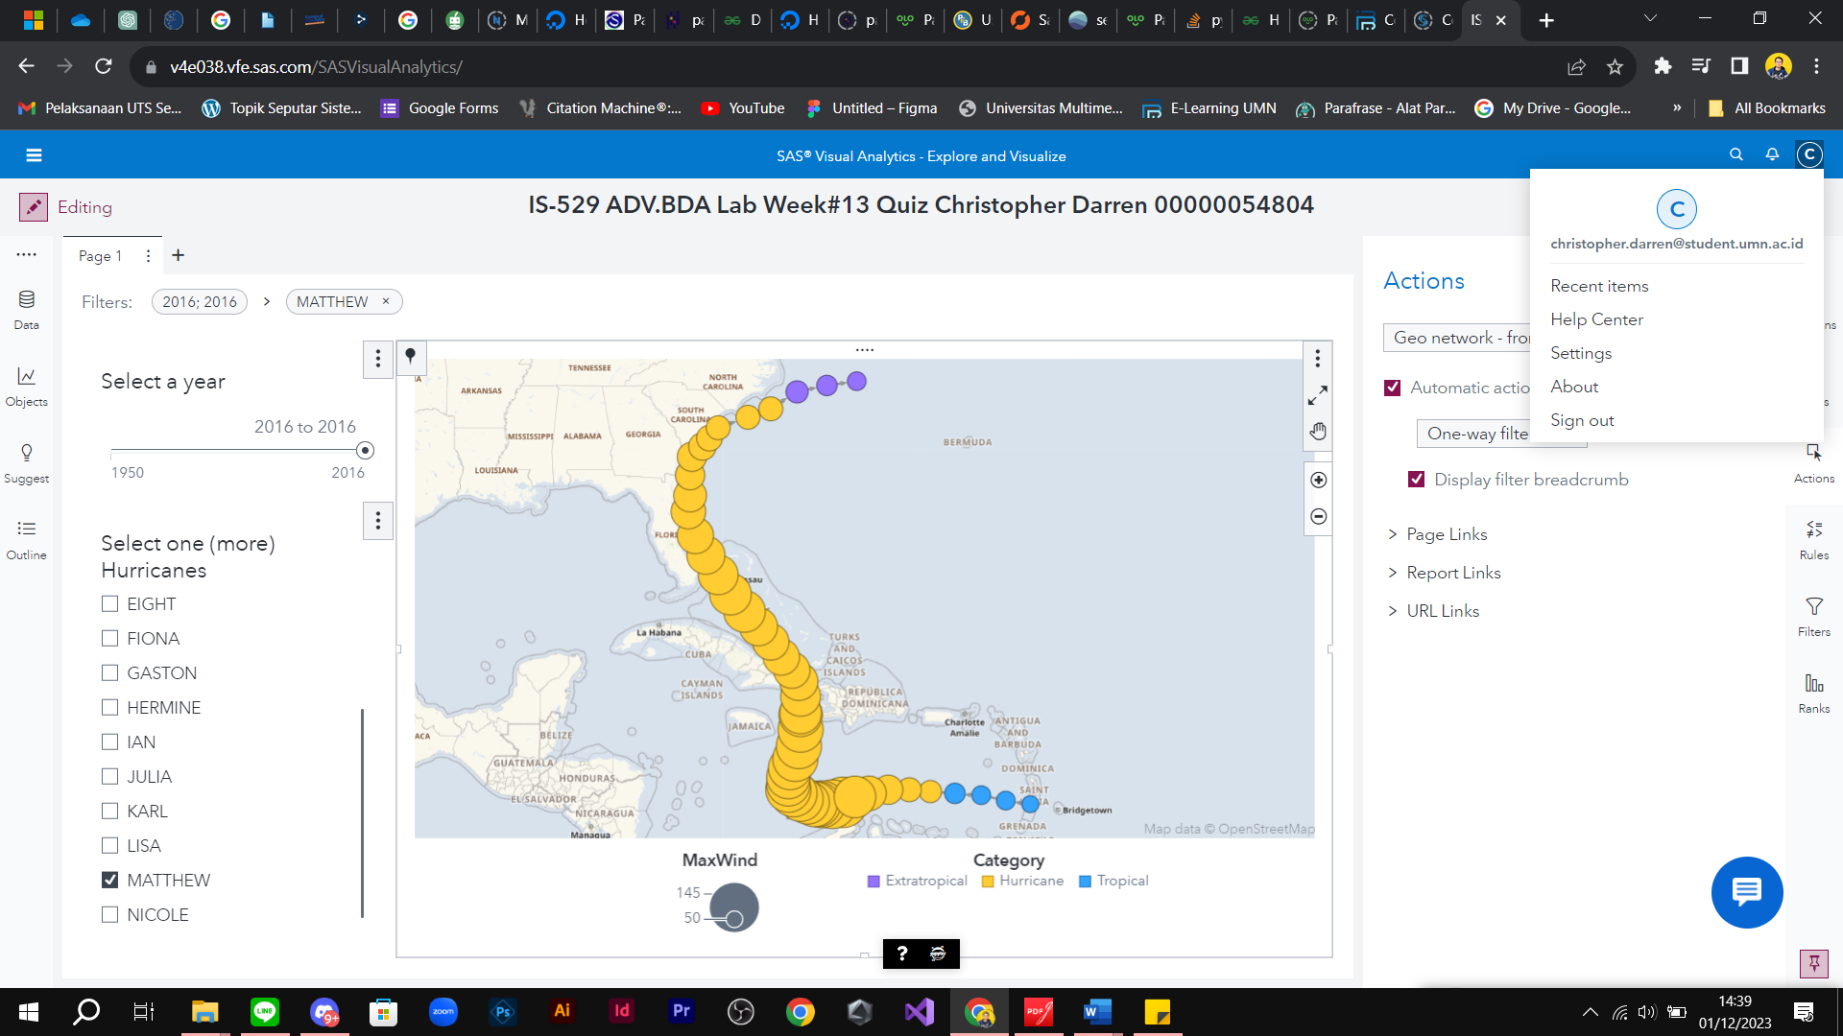

**2) Which states did Hurricane Nicole hit in 2016? What was the maximum wind speed? How was Hurricane Nicole categorized?**

State:

Maximum speed : 120

Categorized: Extratopical, Hurricane & Tropical

